**Select EC2 service-> select Launch template**

**EC2 launch templates**

**Streamline, simplify and standardize instance launches**

**Use launch templates to automate instance launches, simplify permission policies, and enforce best practices across your organization. Save launch parameters in a template that can be used for on-demand launches and with managed services, including EC2 Auto Scaling and EC2 Fleet. Easily update your launch parameters by creating a new launch template version**

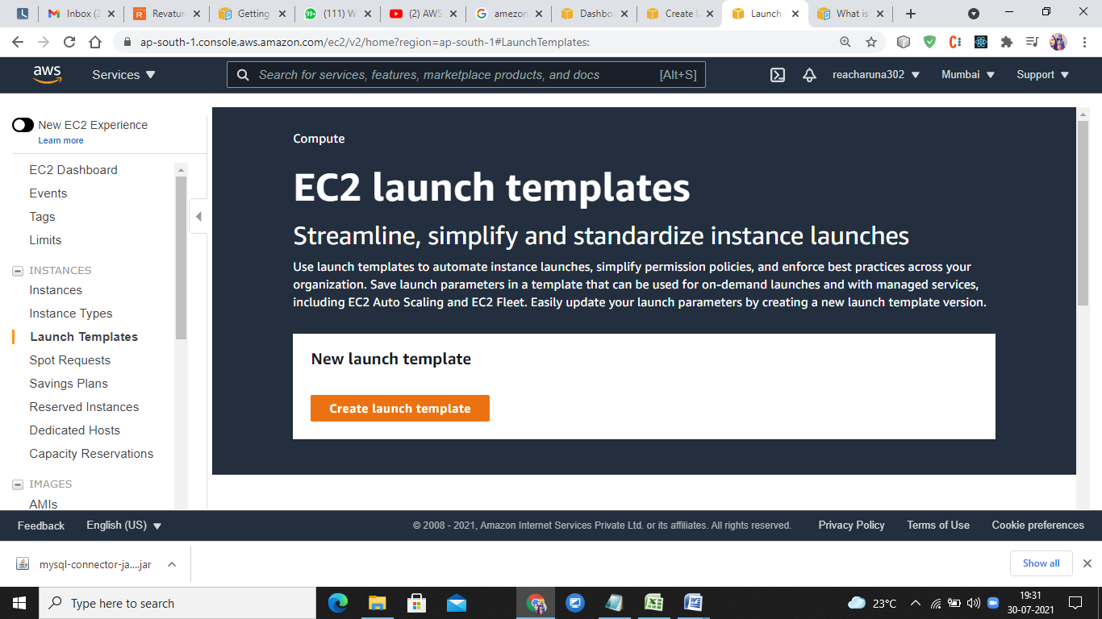

If you already created launch template

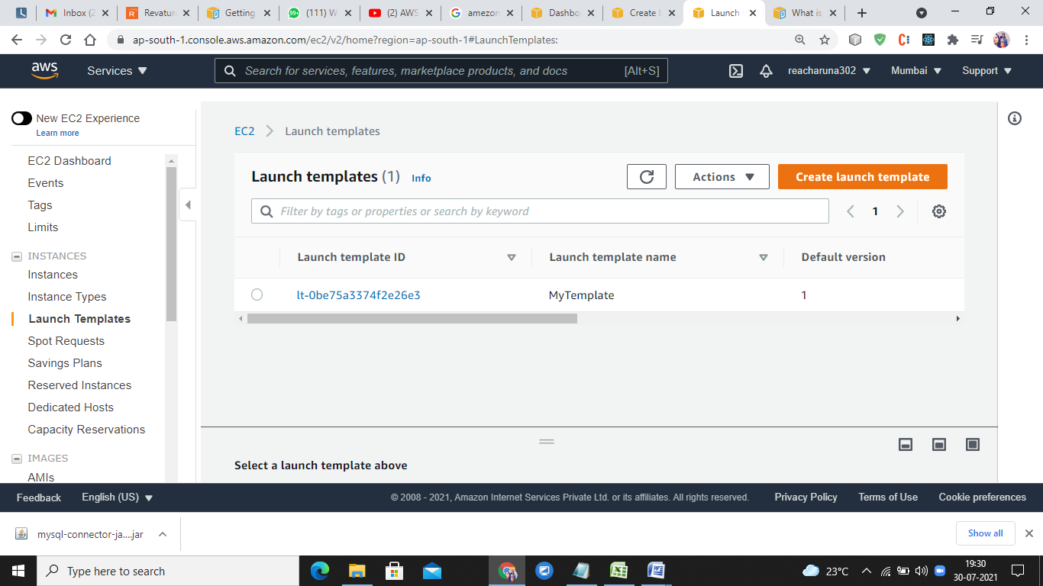

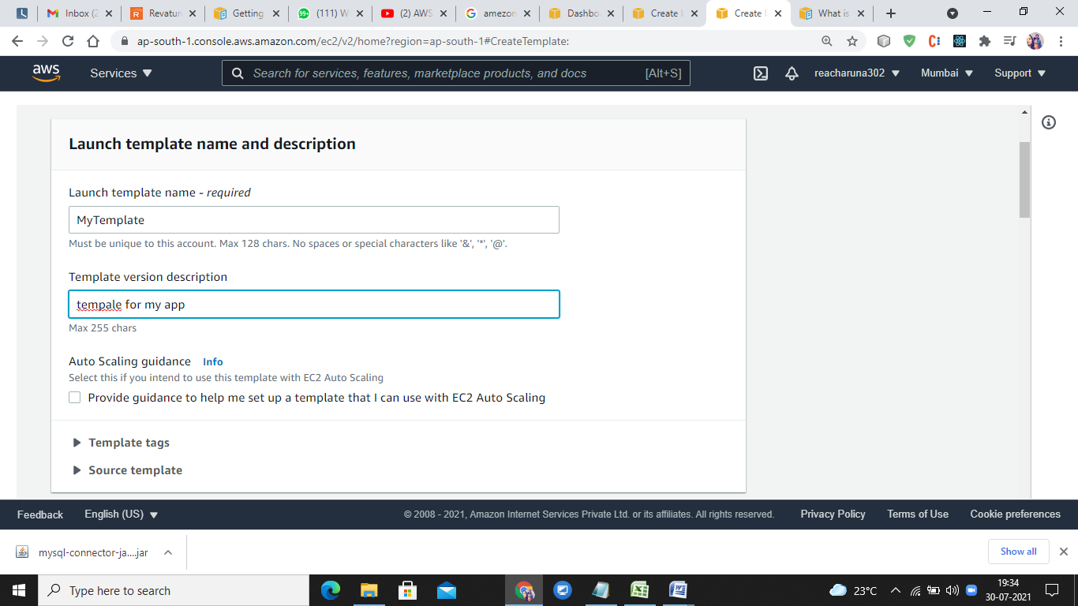

Choose AMI image type, instance type

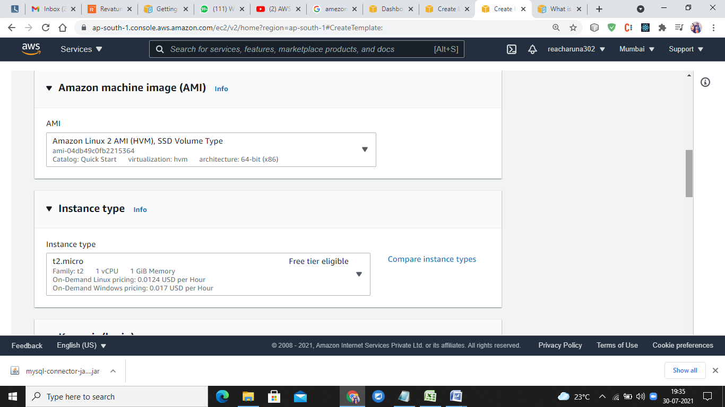

Select keypair and Network settimgs

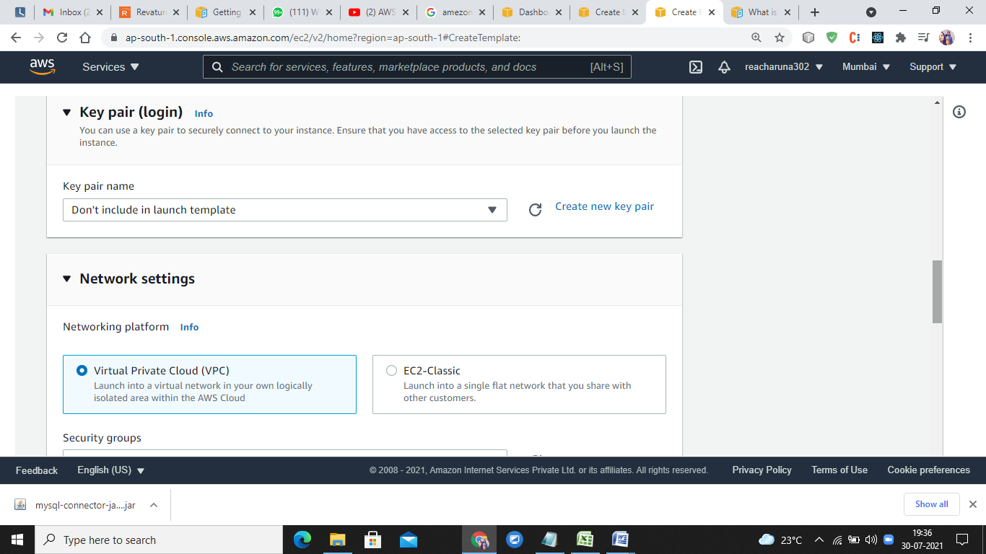

Storage Volumns and Tags

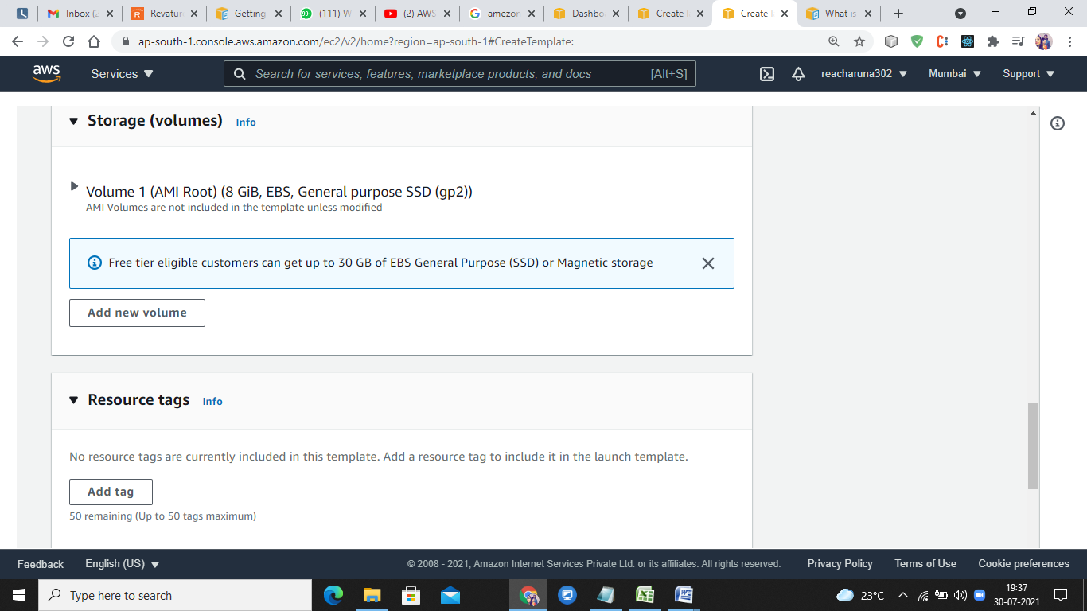

**Network Interface**

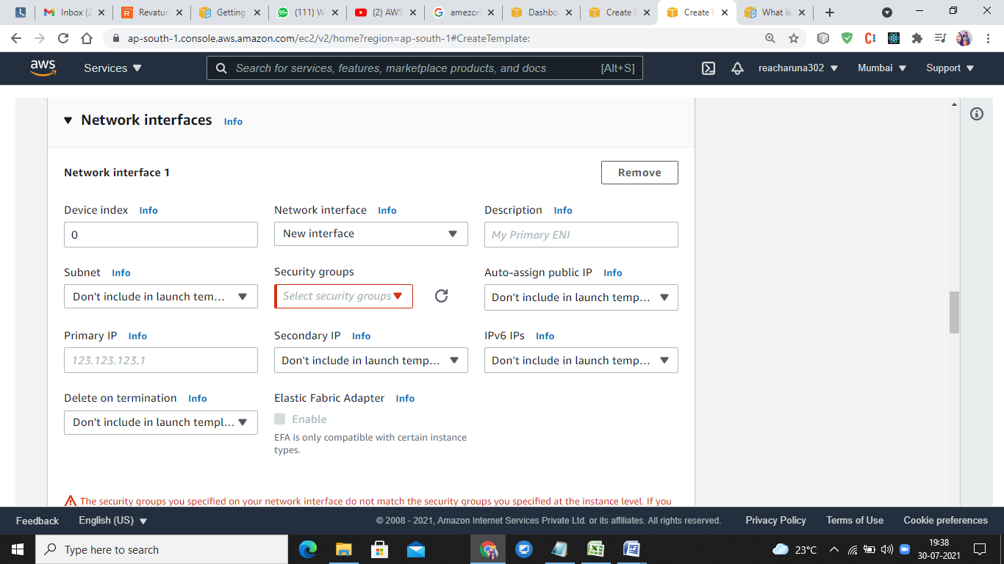

**Advanced details:** Request Spot Instances at the Spot price, capped at the On-Demand price

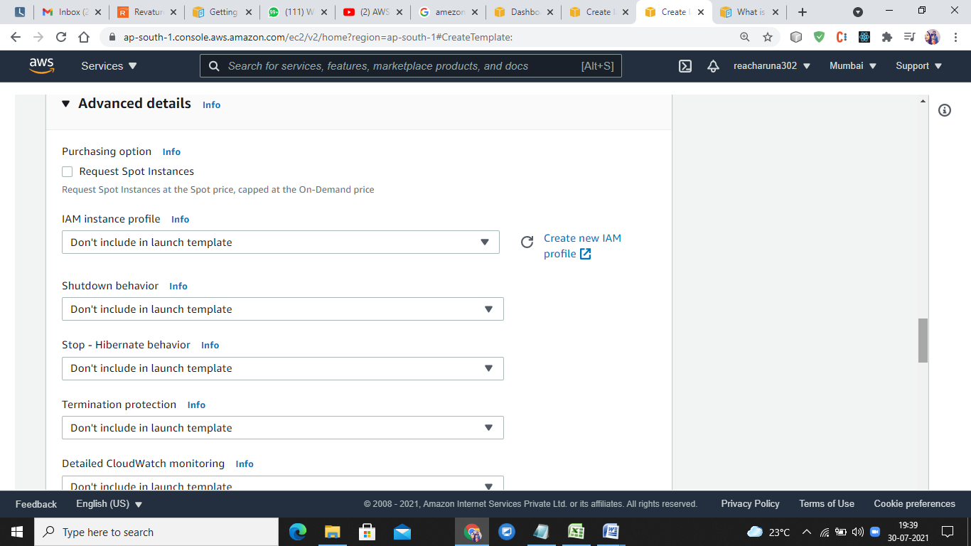

**Create Launch template**

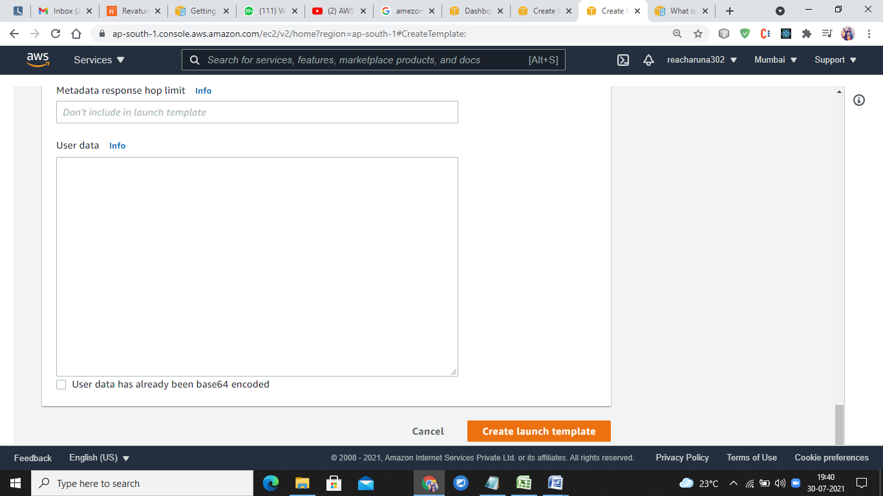

**After Launch Template is created**

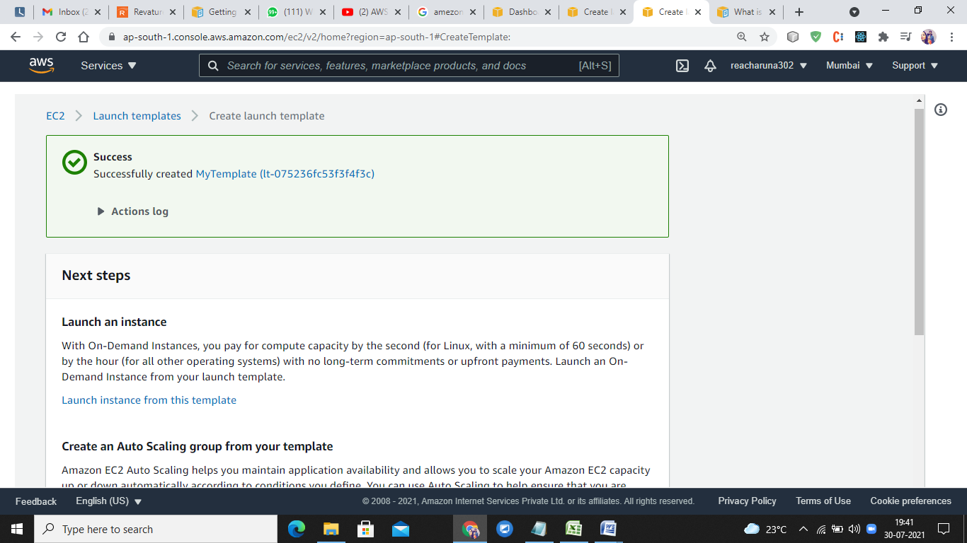

**Launch an instance**

With On-Demand Instances, you pay for compute capacity by the second (for Linux, with a minimum of 60 seconds) or by the hour (for all other operating systems) with no long-term commitments or upfront payments. Launch an On-Demand Instance from your launch template.

**Create an Auto Scaling group from your template**

Amazon EC2 Auto Scaling helps you maintain application availability and allows you to scale your Amazon EC2 capacity up or down automatically according to conditions you define. You can use Auto Scaling to help ensure that you are running your desired number of Amazon EC2 instances during demand spikes to maintain performance and decrease capacity during lulls to reduce costs.

**Create Spot Fleet**

A Spot Instance is an unused EC2 instance that is available for less than the On-Demand price. Because Spot Instances enable you to request unused EC2 instances at steep discounts, you can lower your Amazon EC2 costs significantly. The hourly price for a Spot Instance (of each instance type in each Availability Zone) is set by Amazon EC2, and adjusted gradually based on the long-term supply of and demand for Spot Instances. Spot instances are well-suited for data-analysis, batch jobs, background processing, and optional tasks.

**Template is created :**

